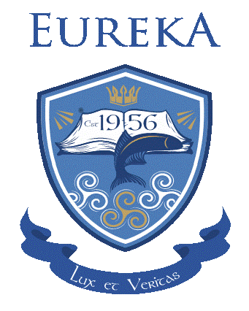

Parent/ Guardian Nomination Form to Board of Management
October 2021 – October 2024

Nominee: _______________________________________
Nominee: _______________________________________

Proposer: ______________________________________
Date: ____________________________

To be returned no later than Monday 4th October via email to principal@eurekaschool.ie or by post to Eureka Secondary School, Cavan Road, Kells, Co. Meath. A82R6C4

